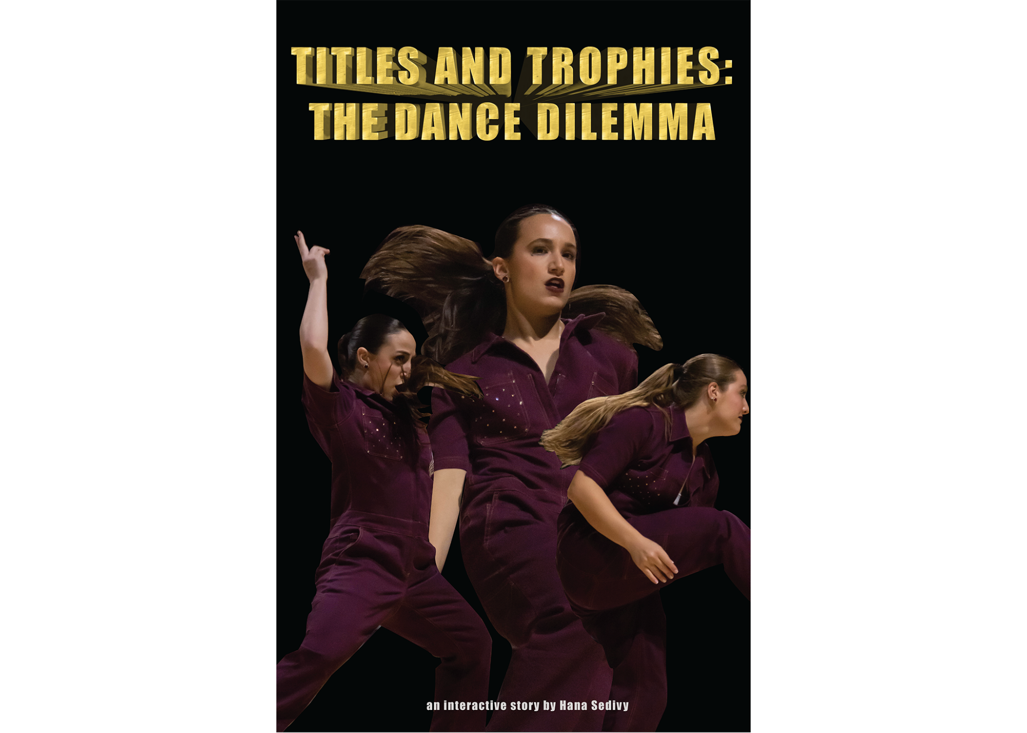
Titles and Trophies: The Dance Dilemma
Capstone Project Summary and Analysis
IME6950: Interactive Media Capstone
Hana Sedivy
Elon University
May 12, 2023

Table of Contents

3……………………………………… Project Type, Goals and Objectives, Target Audiences
3-6 …………………………………………………Description of the Project Topic and Content
6-7 ……………………………………………Technologies and Tools Used to Create this Project
7-11………………………………………………………..………………………… Project Timeline
11-12 …………………………………………………….…………………Project Deliverables
12-15…………………………………………………………..…………………… Research
15-34 ………………………………………………………………………Project Documentation
34-35…………………………………………………………………………………… Credits

Project Overview
Project Type
Titles and Trophies: The Dance Dilemma is an interactive web experience accompanied by a documentary which highlights the similarities and differences between a university dance team and other athletic programs. Although dance teams possess the same athleticism and camaraderie as university football, basketball, or other competition teams, they are not afforded the same technical regulation and protection.
Collegiate dance teams are not recognized as a sport by the National Collegiate Athletic Association (NCAA), the regulatory body for most student athletics. They are therefore not afforded protections that the Title IX legislation was put in place to provide female athletes.

Goals and Objectives
My first objective is to convey what it looks like for dance teams without the enforcement of the Title IX legislation through interviews and B-Roll in a documentary and through clickable videos, animations, quotes, and graphics on an interactive website.
My second goal is to increase awareness about the comprehensive dance team season. Many don’t know that in addition to sideline support, dance team members compete at a national competition and train intensely for it year-round.
A third goal is to accelerate the conversation about dance as a sport. While positioning dance teams in such a way may come with the red tape of technicalities, there is grounds for conversation about why dance teams act as an athletic entity in many spaces, but not others, and, irregardless, are not protected by the Title IX regulation.
I hope that this project justifies the robustness, fortitude, stoicism and power of dance teams. I aim for it to be visible to the changemakers: the NCAA, the Office of Civil Rights (OCR), and the Department of Education. There are many directions this project can go from here- this is just a starting point.

Target Audiences
The target audiences are collegiate dance team members, dance team coaches, dance team families, and interested audience. Secondary audiences are athletic personnel at universities.

Description of the Project Topic and Content
I chose to focus on the NCAA as they are the “largest University Athletic governing body in the world” (American Student Athlete Logistics, 2022, par. 1). The NCAA protects the well-being of athletes at member colleges and universities. There are three Divisions within the NCAA: I, II, and III. Each has different athletic and academic regulations in terms of scholarship, enrollment numbers, financial availability for sports, number of sports per institution, and the amount of games played (American Student Athlete Logistics, 2022).
In my project, the Elon University athletic programs are members of the NCAA. They are Division I. I do follow the Elon University dance team to convey a strong narrative; However, my objective is to tell the stories of dance teams everywhere.
In 1972 the Title IX legislation was passed. This was a massive success for female athletes especially because before it, there was limited opportunity for their participation in sports. The Title IX legislation states that
“No person in the United States shall, on the basis of sex, be excluded from participation in, be denied the benefits of, or be subjected to discrimination under any education program or activity receiving Federal financial assistance (The United States Department of Justice, 2001).”
The athletic provisions of the Title IX law require that schools treat the sexes equally with regard to participation opportunities, athletic scholarships, and the benefits and services provided to male and female teams (American Student Athlete Logistics, 2022). According to the Office of Civil Rights, the regulation broadly ensures and enforces the following:
- an equal number of supplies (uniforms, other apparel, sport-specific equipment, general supplies, instructional devices, and conditioning and weight training equipment).
  - Compliance is assessed among men’s and women’s teams regarding the quality, amount, suitability, maintenance, and availability of equipment and supplies.
- An equal amount of game and practice times.
  - Compliance is assessed by examining the equivalence for men and women of the number of competitive events per sport; the number and length of practice opportunities; the time of day competitive events are scheduled; the time of day practice opportunities are scheduled; and the opportunities to engage in available pre-season and post-season competition.
- Travel and per diem expenses.
  - Compliance is assessed by examining the equivalence for men and women of modes of transportation; housing furnished during travel; length of stay before and after competitive events; per diem allowances; and dining arrangements.
- The opportunity to receive coaching and academic tutoring.
  - Coaching—Compliance is assessed by examining the relative availability of full-time coaches; relative availability of part-time and assistant coaches; and relative availability of graduate assistants.
  - Academic tutoring—Compliance is assessed by examining the equivalence for men and women of the availability of tutoring, and the procedures and criteria for obtaining tutorial assistance.
  - Assignment and Compensation of Coaches and Tutors (§ 86.41(c)(6)). :
“In general, a violation of Section 86.41(c)(6) will be found only where compensation or assignment policies or practices deny male and female athletes coaching of equivalent quality, nature, or availability.” (OCR, 1979).
- The provision of locker rooms, practice and competitive facilities.
  - Compliance is assessed by examining the equivalence for men and women of the quality and availability of the facilities provided for practice and competitive events; the exclusivity of use of facilities provided for practice and competitive events; the availability and quality of locker rooms; the maintenance of practice and competitive facilities; and the preparation of facilities for practice and competitive events.
- The provision of medical and training services and facilities.
  - Compliance is assessed by examining the equivalence for men and women of the availability of medical personnel and assistance; health, accident and injury insurance coverage; availability and quality of weight/training and conditioning facilities; and the availability and qualifications of athletic trainers.
- The provision of housing and dining services and facilities.
  - Compliance is assessed for men and women through examining the provided housing and special services as part of housing arrangements (e.g., laundry facilities, parking space, maid service).
- Publicity.
  - Compliance is assessed by examining, among other factors, the equivalence for men and women of: the availability and quality of sports information personnel; access to other publicity resources for men's and women's programs; and the quantity and quality of publications and other promotional devices featuring men's and women's programs.
- The effective accommodation of student interests and abilities and the Determination of Athletic Interests and Abilities (Application of the Policy).
  - Institutions may determine the athletic interests and abilities of students by nondiscriminatory methods of their choosing. They can take into account the nationally increasing levels of women's interests and abilities; demonstrate that their methods of determining interest and ability do not disadvantage the members of an underrepresented sex; that their methods of determining ability take into account team performance records; and/or that their methods are responsive to the expressed interests of students capable of intercollegiate competition who are members of an underrepresented sex.
- Compliance in Financial Assistance (Scholarships) Based on Athletic Ability.
  - The governing principle in this area is that all such assistance should be available on a substantially proportional basis to the number of male and female participants in the institution's athletic program.
(OCR, 1979).

Because the NCAA recognizes a sport as

“an institutional activity, sponsored at the varsity or club level, involving physical exertion for the purpose of competition against teams or individuals within an intercollegiate competition structure…” (NCAA, n.d.)

dance is not considered a sport because they do not exist for the sole purpose of competition. Dance teams are popularly seen supporting other athletic teams from the sidelines, accordingly being designated to club and spirit departments, depending on the college. Without the technical athletic title, the Title IX regulation is nearly absent from the dance team infrastructure. Each of the above provisions are not pertinent to dance teams. No one is enforcing the legislation that advanced equality for women into a predominantly female activity such as dance.
Without Title IX protections, there is disparity between resources granted to dance teams and those given to sports teams. The Elon Dance Team does not receive academic tutoring, the assistant coaches are not compensated, the team does not have a locker room, and they do not receive the same catered attention and resources from athletic training offices. The team’s most reliable practice space is a gym that is operated separately from the athletic department, often not heated in the winter nor air conditioned in the summer. They do their own physical conditioning, their social media accounts are run by dance team members themselves, they currently receive no scholarship, and in the past sixteen (16) years the team has endured eight (8) coaches, says former dance team supervisor Rhonda Belton (R. Belton, personal communication, December 4, 2022).
As a former Elon dance team member, Elon Dance Team Assistant Coach Kristin Sicari felt an absence of practice space and academic counseling, even admitting she most often practiced in gym atriums and parking lots, and had conflicts registering for classes that fell during practice times. Sicari said that she has seen some of this smoothed out for the Team in recent years if only because of Head Coach Elly Dirks’ recent full-time position in Elon Athletics (as of 2022) and the dance team’s national championship win in 2022 (K. Sicari, personal communication, December 4, 2022)
If dance were considered a sport by the NCAA, teams would receive the Title IX protections that provide space for more funding, qualified coaches, accessibility to certified athletic trainers, better practice facilities, academic tutoring, and more. Just because dance is aesthetics/performance-based does not mean it should be doubted as a sport. In fact, athletes who participate in aesthetically-pleasing sports like figure-skating and gymnastics often train 30 or more hours per week. This trend starts at a young age, resulting in an entirely athletic identity (Rich et al., 2022, p. 4). Without an identity outside of sports, these athletes transition into retirement with feelings of denial; eating disorders, substance abuse, and anxiety and depression (p. 4). If dance team was officially considered a sport, it would fall into an “aesthetically-pleasing” category. This furthers the need for the protections and assistance that Title IX provides.
In Titles and Trophies: The Dance Dilemma documentary, the viewer navigates a dance team season behind the scenes, bearing witness to the action that unfolds when the nationally-ranked team has to move around tables and chairs to practice in a basketball gym. We follow dance team graduates from North Carolina State University and Elon University, five-year dance team members, and others, and we listen to how they deal with situations as they relate to the lack of particular Title IX provisions. The viewer also watches as the team unites and ascends despite challenges. The documentary focuses on 5 provisions. First: The effective accommodation of student interests and abilities and the Determination of Athletic Interests and Abilities (Application of the Policy). Second: Compliance in Financial Assistance (Scholarships) Based on Athletic Ability and the opportunity to receive coaching and academic tutoring. Third: The provision of medical and training services and facilities. Fourth: Equal number of supplies. Fifth and finally: The provision of locker rooms, practice and competitive facilities.

Technologies and Tools Used to Create this Project
Ceros
Adobe Premiere Pro
Adobe Illustrator
Adobe Photoshop
Canon EOS 7D Mark II (50mm, 24-70mm, 70-200mm EF Mount)
Tripod
Senheisser Camera Top Mini Mic
G3 Wireless Mic
Zoom Recorder
Genaray Lighting Kit
Universal Production Music
StudioBinder
Trello

Project Timeline
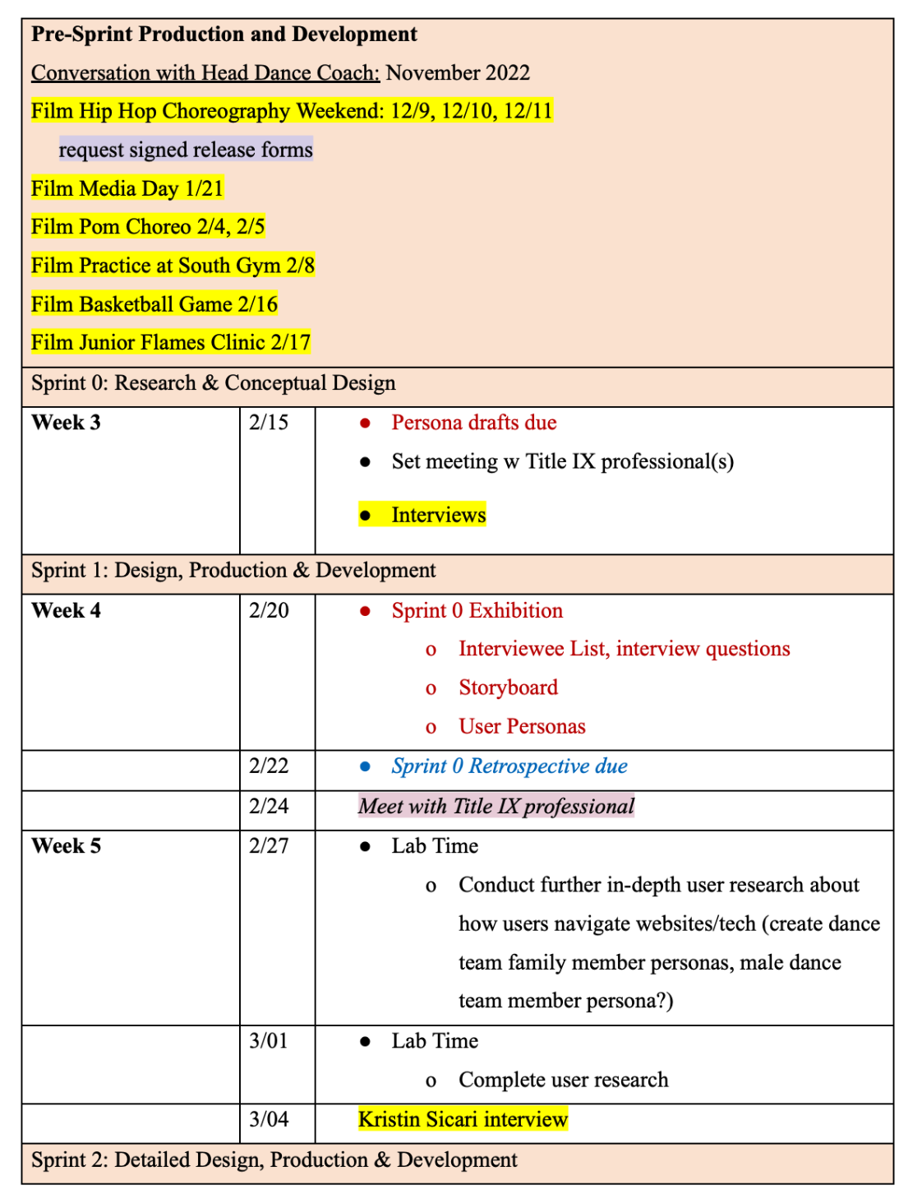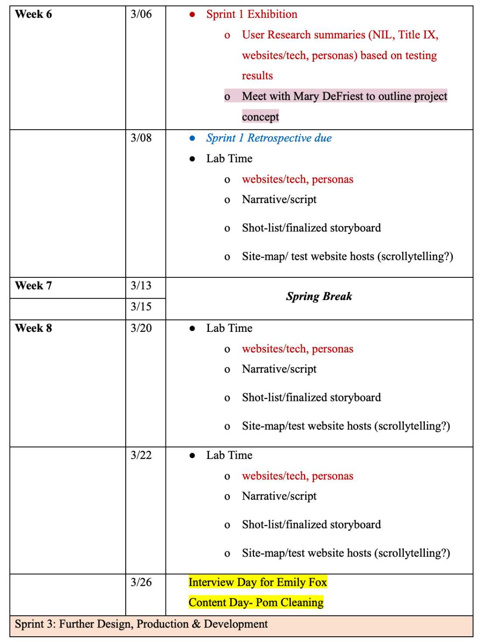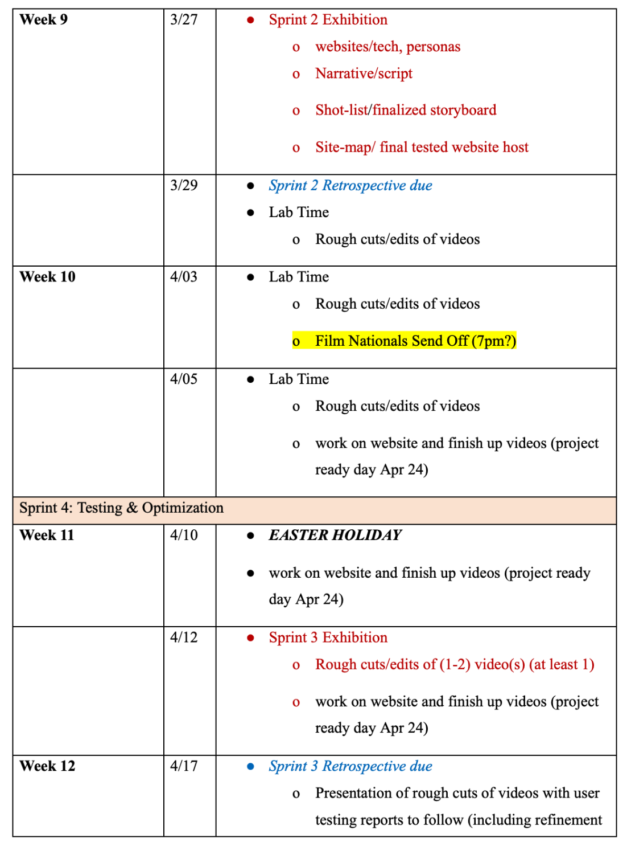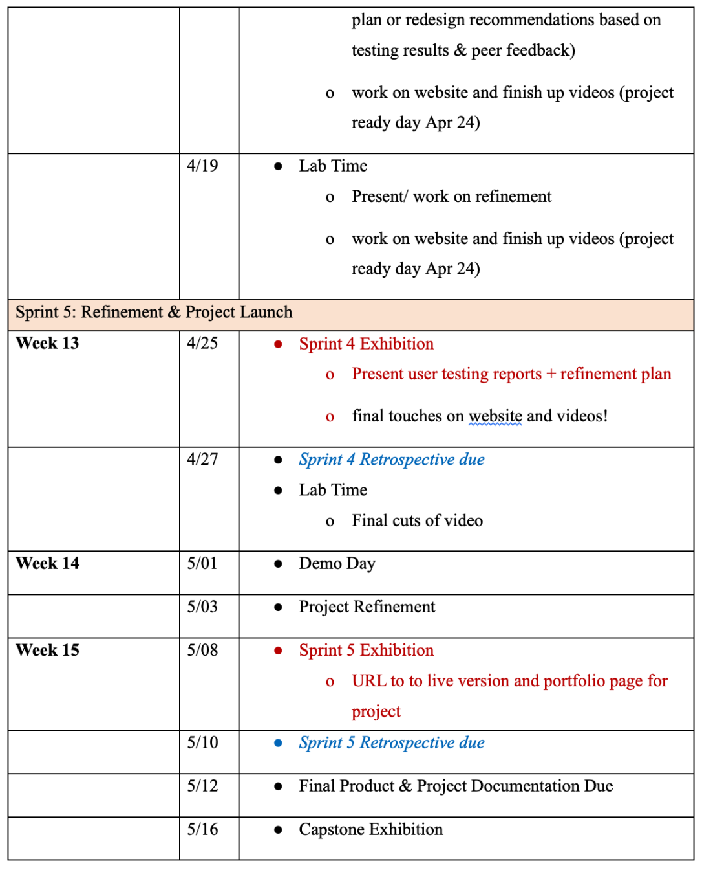

Project Deliverables:

- The interactive website which includes a trailer video and the full 20 minute documentary Titles and Trophies: The Dance Dilemma: https://view.ceros.com/elon-university-imm/t-and-t-official .

- Individual Youtube link to the trailer video about Titles and Trophies: The Dance Dilemma: https://youtu.be/P-ljRltiAAk

- Individual Youtube link to the documentary Titles and Trophies: The Dance Dilemma: https://youtu.be/Omk_bWREzjo

Research
The background research that I conducted for my project include the following:

I researched Name, Image, and Likeness (NIL) policies because I wanted to see how dance teams may or may not benefit from them. For years, the NCAA has used the name, image and likeness of college athletes to promote NCAA athletic programs and drive revenue. The NCAA’s interim NIL policy allows student-athletes to be compensated for the use of their NIL. For many people there are positives and negatives to NIL or the “right of publicity” which is a legal concept used to either allow or prevent the use of an individual to promote a product or service. Critics say the NCAA takes advantage of student-athletes by using their name, image and likeness for profit, while not allowing the athletes to cash in, as well. The following are a few examples of what student-athletes can currently be paid for:
- Their autograph
- Developing and/or modeling athletic and non-athletic clothing apparel
- Promoting products and services
- Making personal appearances (NCAA, par. 6).
Athletes are expected to understand their school’s NIL policy and keep their school informed of all NIL arrangements. Platforms like INFLCR and Opendorse allow athletes to upload their NIL contracts for compliance departments to review and approve). On February 27, 2023 Elon University Athletics announced the launch of their NIL Network “Forever Phoenix” in partnership with Opendorse (Knavel, 2023). Opendorse CEO Blake Lawrence said …any fan or brand can support Elon players in seconds, empowering all Phoenix student-athletes to maximize their NIL potential (Knavel, 2023). Lawrence adds:
“Every Elon student-athlete has the opportunity to create an Opendorse profile, which allows staff to share visual media and messages directly to the student-athlete. Student-athletes can then access media instantly on-demand and publish via a single tap, allowing them to build their personal brands. They can customize their Opendorse profile and promote to fans on their personal social media channels.”
Opendorse is the leading technology provider in the athlete endorsement industry. More than 75,000 athletes use Opendorse to understand, build, and monetize their name, image, and likeness with support from thousands of brands, fans, sponsors, donors and partners including Team USA, PGA TOUR, NFLPA, MLBPA, WNBPA, LPGA, over 100 professional and collegiate sports teams (Knavel, 2023).
The most significant part about Elon’s Forever Phoenix Network, in terms of this project, is that dance team members are able to participate. Unofficially, to obtain an NIL deal, you should have a social media presence and status as a collegiate athlete. Elon Dance Team’s ability to receive NIL deals is an incredible step in the direction of growth that dance programs deserve. If dance teams are inconsistently present in official athletic spaces, why not make it consistent for all dance teams?

I also investigated the differences between athletic conferences. This concept is introduced on page 3 with the breakdown of the NCAA’s divisions, but in addition to the NCAA there are large governing organizations like the National Association of Intercollegiate Athletics (NAIA), and the National Junior College Athletics Association (NJCAA). Compared to the 460,000 athletes that participate in the NCAA annually, 65,000 compete with the NAIA (American Student Athlete Logistics, 2022). Different restrictions exist within the NCAA than for the NAIA in terms of athlete eligibility. A significant aspect of the NAIA is that they have held seven (7) National Championships for dance and dancers are therefore considered student-athletes within the organization (NAIA, 2023). NJCAA institutions have the least restrictions of the other two. They are two-year programs which means athletes must transfer after the two years.
Additionally I looked into Stunt as an emerging sport for women. According to USA Cheer (2023), Stunt was passed as an emerging sport for NCAA Division II in 2023 and will be effective in August of 2023. Stunt focuses on the technical and athletic components of cheer which include partner tricks, pyramids, basket tosses, jumps and tumbling. This is a crucial step forward for cheerleaders and dancers alike and encourages further conversation and growth for the programs in every division.
I researched dance teams at schools outside of Elon like Louisiana State University and St. John’s University to compare and investigate stories. The dance and cheer teams at Louisiana State University (LSU) and St. John’s University are not the first to speak out about feeling underprivileged.
In 2021, for the first time in 22 years, LSU barred their dance team from competing at nationals for reasons unrelated to the COVID-19 pandemic or financial strain, which many dance teams were burdened by that year. The university implemented the restriction due to the team’s lack of athletic trainers for the season (Price, 2022, p. 31). The LSU Dance Team, also known as the Tiger Girls, were required to dance at football, basketball, and gymnastics events. They created a Change.org petition and received 27,456 signatures in an effort to change the university’s mind (Price, 2022, p. 32). The team was still prohibited from competing. In 2022, back with a vengeance, the Tiger Girls competed at nationals in the Division IA Hip Hop Category to music artist Ciara’s “Like a Boy.” The piece was a commentary on female athletes who have been neglected in relation to their male counterparts while putting “revenue sports” at the forefront (Price, 2022, p. 33). The routine took first place.
St. John’s University received backlash from its cheer and dance squads and fans after failing to recognize the teams for National Girls and Women in Sports Day on February 1st, 2023. The cheer team refused to perform at a February 3rd basketball game after St. Johns’ failure to tag the dance and cheer teams in an Instagram post that recognized their women sports teams (Hart, 2023). One St. John’s instagram follower wrote:

"Extremely disappointed as a @stjohnscheer alumni that you don't recognize these hardworking women. That show up to every single event needed FOR the university! As well as @sju_dance…"

There is a strong belief that dance teams (as well as cheer teams) are deserving of falling into the category of “sport.” There is also some confusion about what dance teams really do, and what prevents dance teams from being a sport. This is what my project aims to investigate and clarify, and also why the project is relevant.
I aim for this project to enhance diversity, equity and inclusion by promoting accessibility to the resources granted by Title IX to other athletes. Dance team is a female-dominated, aesthetics-based, athletic activity, and this project aims to empower the community and uplift the men who, while not present among the specific team in the Titles and Trophies documentary, do also participate in dance teams.
In order to enhance my knowledge about the Title IX regulation I interviewed a Title IX professional who ultimately decided to remain anonymous; I was able to confirm and build on the knowledge I gathered from that interviewee from web sources such as the Department of Justice, the Department of Education, and the Office of Civil Rights. Much of my Title IX research is listed on pages 3-6. I interviewed 11 dance team members, 2 dance team assistant coaches (former dance team members), and former dance team supervisor Rhonda Belton. I also spoke with Mary DeFriest, Director of Marketing and Fan Engagement and Supervisor to the Elon Dance Team about her experience working within the athletic department as well as with a spirit squad.
I proposed this project to the Director of Elon University’s Interactive Media program, Derek Lackaff. The written documentation in this proposal included much of the above research, the project’s relevance, project needs and budget, a need’s assessment, external contingency plan, literature review, prototype evaluation, individual learning plan, and potential project consultants.
User research was conducted on a group of dance team members, dance team assistant coaches and dance team parents. I created user personas for dance team members and dance team parents after interviews with these subsets of people.
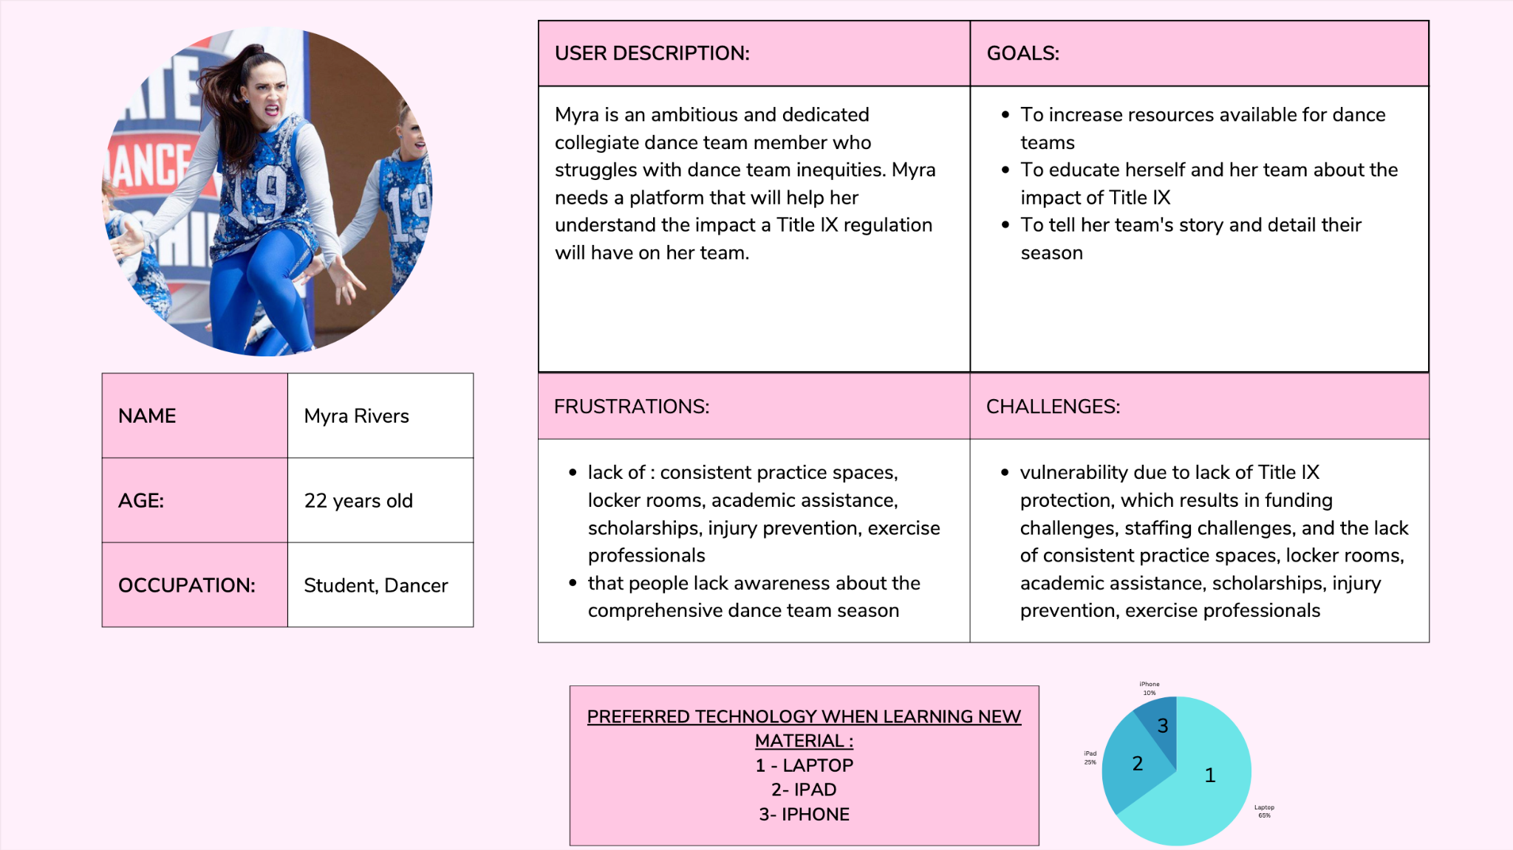
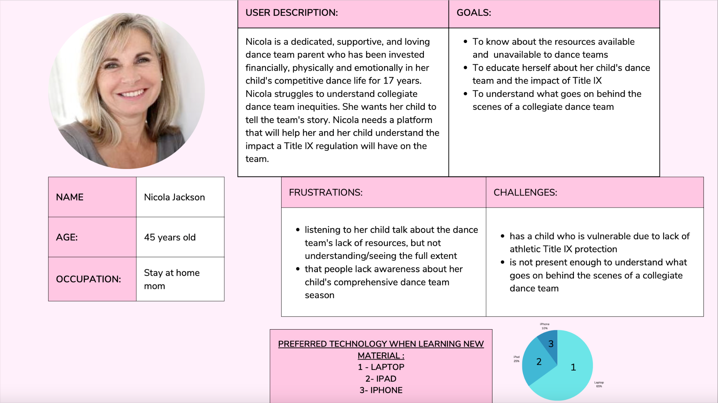
For both personas, they felt a desire to increase their understanding of Title IX, and both simultaneously felt vulnerable without the presence of the regulation. I requested information about technology usage to know what to design my interactive website for. Most people (65%) used laptops when learning about something new. 25% used an iPad and 10% used an iPhone.
I conducted an hour-long usability test for the trailer of Titles and Trophies: The Dance Dilemma as well as the full 20 minute documentary. Six (6) users were asked a series of qualitative and quantitative questions via Google forms. Quantitative responses were collected through Excel and qualitative responses were collected through a group discussion at the end of our session. A refinement plan was created following the test, based on feedback which included but was not limited to: the depth and clarity of the Title IX explanation, audio fine-tuning, enhancing B-Roll, adding closed captioning to specific sections, and cutting certain sections that feel too long.

Process Documentation

*Many of the following documentations are retrospectives, written several months ago. This section is meant to highlight my process.*

Sprint 0

According to my backlog, the specific tasks planned for completion during Sprint 0 were an interviewee list, the interview questions, a storyboard and user personas (personas on page 14-15).
In support of creating the interviewee list and interview questions, I discussed with dance team members and coaches their passions, struggles, goals, frustrations and motivations. I developed a close connection with the team and conducted many interviews which provided context to create user personas (one being a dance team member and another being a dance team parent). The interviews allowed visuals for a storyboard and I found myself to be ahead with interviews and video content; however behind with user research and a shot-list. It seems I may have conducted user research first, then personas, created a shot-list thirdly, followed by a storyboard. I could have conducted interviews after that; Regardless I will aim to produce excellent artifacts and end product. I wasn’t able to gather as much detail, accuracy, and information about both of my personas in terms of technology know-how and background as I wanted to. I also wasn’t able to storyboard as extensively as I imagined because of the site I chose to do it on, but I was happy with the way my storyboard turned out on StudioBinder and may consider paying for the service. Things are moving so quickly that I wish I had more time to edit my elements from Sprint 0 with the feedback that I got from my team.
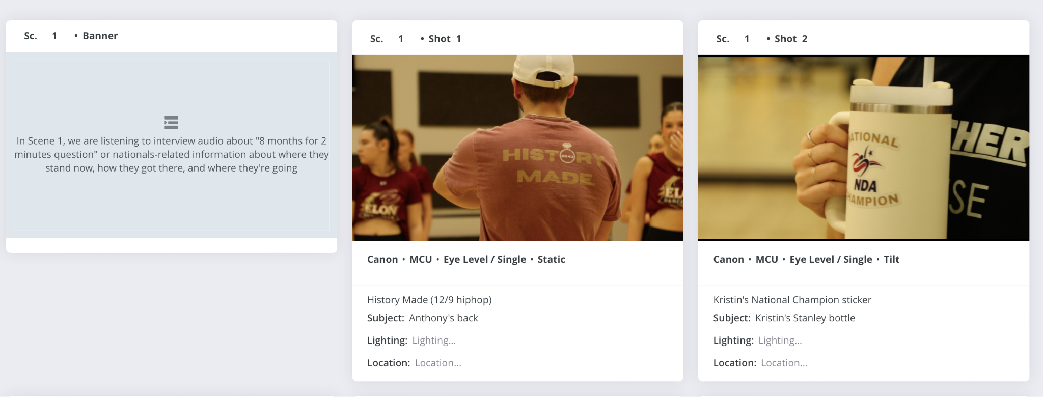
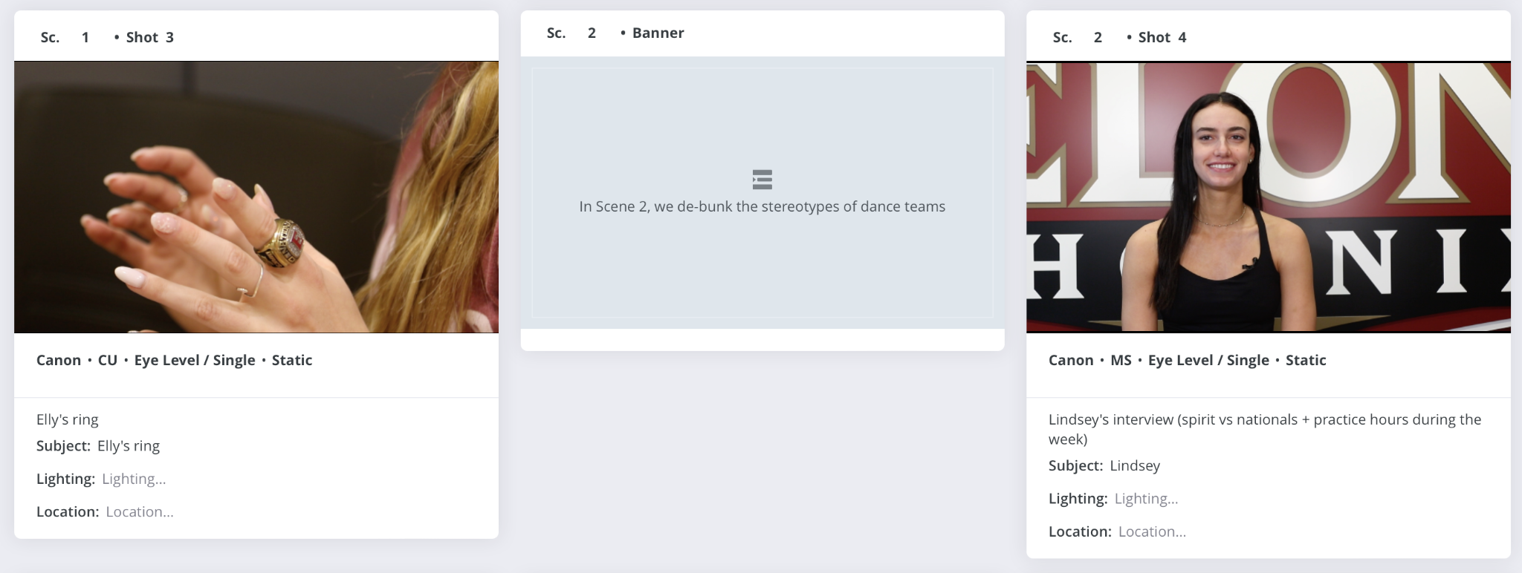
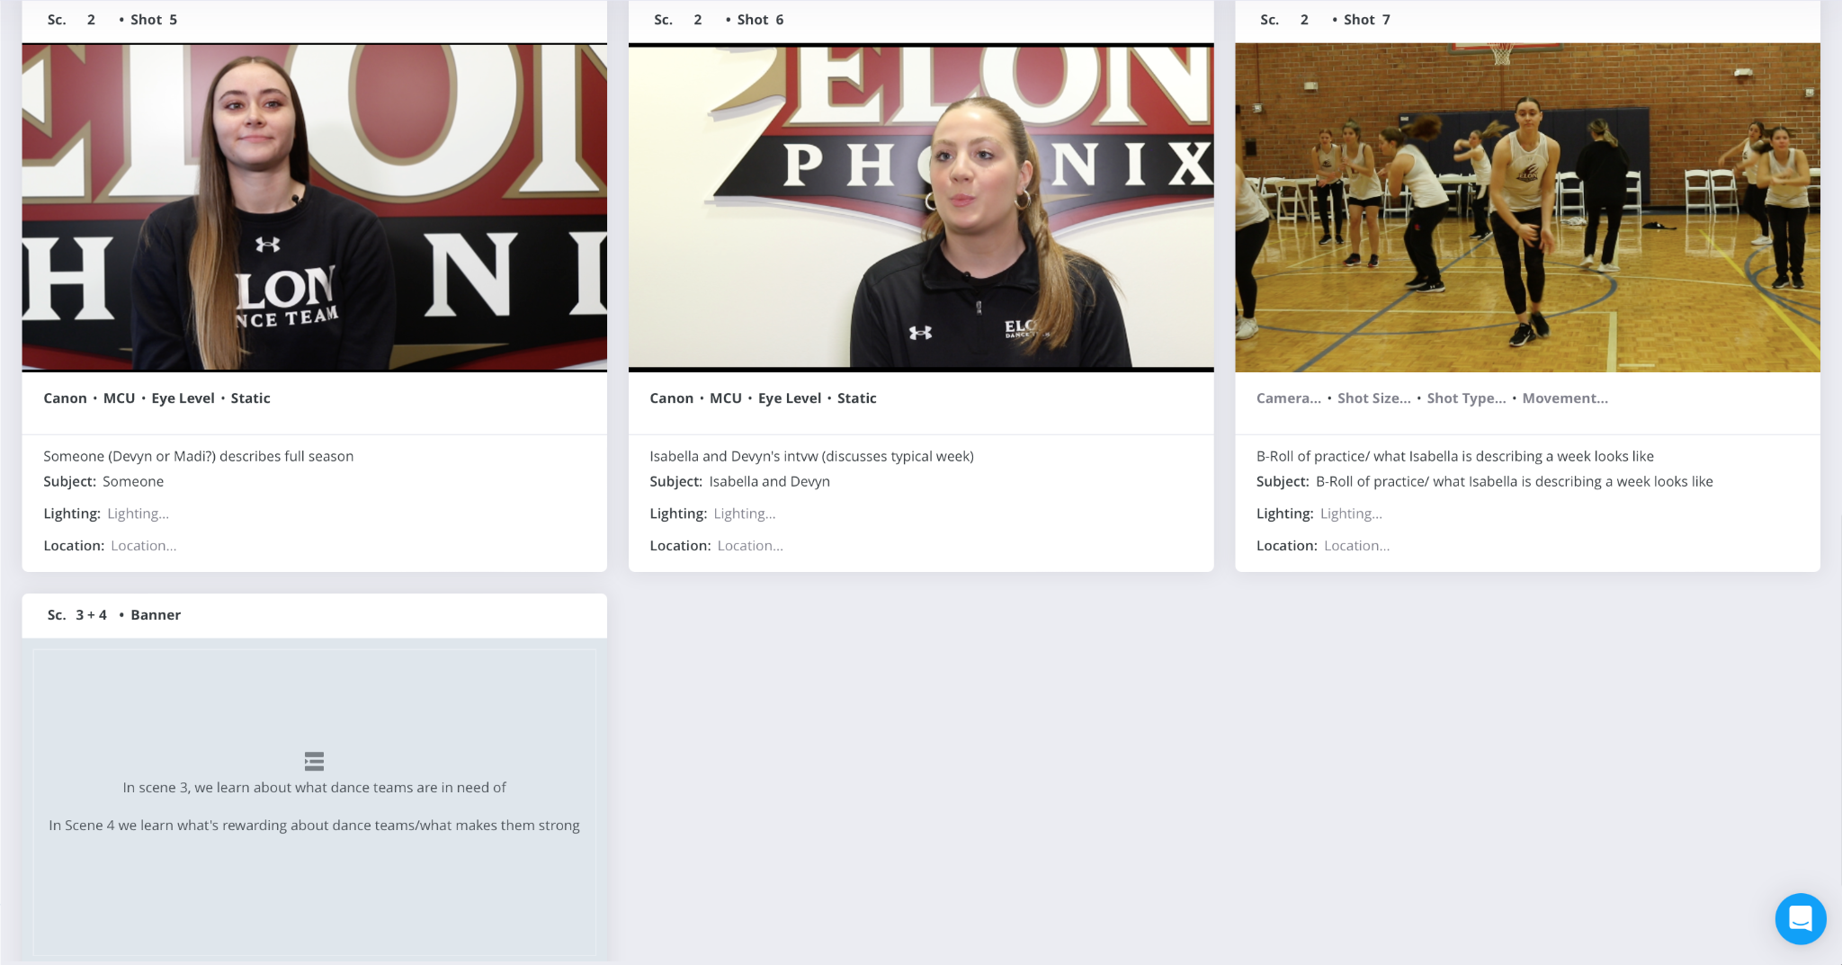
Interviewees:

Ava DeBruin
Sarina Jackowski
Devyn Battaglia
Lindsey Rothenstein
Phoebe Gamponia
Madison Valgardson
Melina Steenberg
Henna Reid
Isabella Venziale
Sarah Whiting
Sophia Gallagher
Kristin Sicari
Emily Fox

Off-camera interviewees:
Rhonda Belton

Interview Questions

Ava: What are the facilities like at NDA Camp? What are the resources offered? + How many hours are you dancing at NDA Camp throughout the weekend? Where do you practice routines at NDA Camp?

Dancers + Ava/Sarina: What will you be most proud of after leaving this program?

Dancers + Ava/Sarina: What will you remember most distinctly about this program?

Ava/Sarina: What has been your biggest challenge throughout your 5 years on the team?
Dancers: What has been your biggest challenge throughout your years on the team?

Ava/Sarina: Can you talk about the history of the program and how much it’s changed since you’ve been on the team?

Kris: What’s the craziest story you have or your craziest experience from your time on the team?

Kris: Do you have a designated practice space on campus?

Kris: Do your dancers have classes that overlap with practice times or has there been a history of that happening frequently?

Kris: Where do your dancers stay during preseason in the summer? Has it historically been easy or difficult for them to find housing during that time period?

Vets: Who do you go to on campus when you have an injury and how do your methods compare to other athletes at Elon, if at all?

Kris: How have dance team injuries been dealt with in the past and has it changed since you were on the team?

Kris: Is it challenging to raise money for the team without status as a club sport or an NCAA sport? How do you raise money?

Kris: Has it ever been challenging to pay for dance team necessities like costumes, poms, warmups, anything? Why?

Kris: How many clinics have you hosted this year? / How did your most recent Junior Flames Clinic go?
How much interest is there in the Elon Dance Team this year and how has that changed recently?

Kris or vets: Does your involvement in the NCAA’s Student Athlete Advisory Committee give you room to provide insight on the dance team experience despite your exclusion from the NCAA?

Vets: Can you describe the process of pre-season, competing at NDA camp in August to receive a Nationals bid, and ultimately competing at Nationals in April?

Vets: Have you been treated any differently since you won a national championship in April of 2022?

Emily, Kris: How many jobs do you have? What are they? Why?

Kris: When you were on Elon’s dance team you wore NDA Nationals-themed T-Shirts that said “8 Months for 2 minutes.” Can you describe the meaning behind that?

Emily, Kris: The first lyrics to your Nationals Hip Hop dance are from J Cole’s song The “Climb Back”. They say “Are you doing this work to facilitate growth or to become famous? Which is more important? Getting, or letting go? Do these lyrics mean anything to you?

Emily: What is Nationals like?

Emily, Kris: What kinds of challenges do you deal with or have you dealt with in terms of dance-team related sexual harassment? Is there a stereotype that comes with being a dance team girl? How do you deal with that?

Is there a particular challenge that accompanies dance team-coaching?

Emily, Kris: What’s the most rewarding part of coaching?

Emily, Kris: Do you have a favorite dance team memory?

Kris: What makes the EUDT especially strong or unique?

Emily, Kris: What do you think draws people into being on a dance team and what keeps them dancing?

Emily, Kris: Why do people get collegiate dance teams and collegiate cheer teams confused?

Emily, Kris: How do you feel about Elon’s “Forever Phoenix” NIL Network? What will partnership with Opendorse do for the dance team?

Kris: Can you talk about the history of the team and how far it’s come?

Kristin: How is your assistant coach position different from other assistant coaches?

Kristin: How did you get involved with the team?

Emily: Can you talk about the challenges you encountered throughout your dance team experience?

Everyone: What’s required to maintain a spot on the Elon Dance Team?

Everyone: How long is a regular dance team season?

Everyone: What’s something that people may not know about collegiate dance teams?

Everyone: What kind of resources do you receive from the university that are similar to other athletes?

Everyone/Kris: Can you describe your participation and service to the community?

Anyone:How do you decide what workouts are best for dancers?

Everyone: Would you want the dance team to become an NCAA sport worthy of Title IX resources such as athletic scholarships, academic tutoring, potential added locker room space?

Anyone: What does a typical week look like for you, inside and outside of dance?

Rookies: What’s one thing you would tell an incoming freshman or to anyone interested about a dance team that was really surprising to you?

Lindsey: How often is the turnover that’s required for routines? (How long does it take to learn a dance, how often is a dance performance needed, who teaches it)

My plans for my project haven’t changed since the beginning of my sprint. The overall nature of my project is to tell the story of dance teams, emphasize their athleticism, explain how they are in a position to be a sport, what being a sport would mean for them, and why they aren’t a sport now and what impact that has on them without a Title IX regulation. My intended audiences are still dance teams, dance team families, and interested audiences. I went in with a fire under me with this project topic because it is something that is close to my heart as a dance team alumna. I had assumed that most dance-team members and coaches would support dance becoming a sport, but I reconstructed my interview questions to be unbiased when I realized that not everybody in the dance world may want dance to become a sport because of the bureaucracy that comes with it. If that’s the case I plan to unearth the “why” behind that, see who the reasoning is coming from, and address that in my videos or external documentation.
Sprint 1
According to my backlog, the specific tasks planned for completion in Sprint 1 were to complete NIL research, Title IX research, and to research more extensively how my audience preferred to navigate websites and watch videos. The specific work I completed in support of my NIL research was to write an official summary after investigating the launch of Elon’s “Forever Phoenix” NIL Network. This led me down a rabbit hole of what NIL actually is, how athletes can get deals, the positive and negative connotations to NIL, what the NCAA has to do with it, platforms associated with NIL like Opendorse, whether or not dance teams can get NIL deals, and more. I also wrote a summary about what I learned about Title IX after my interview with an anonymous source, corroborated by web sources like the Department of Justice. My research summary about Title IX is found in this documentation on pages 3-6. The summary about NIL is found on page 12. I hit a blocker because my Title IX interview source decided against signing my release form which would’ve allowed me to publish my findings from them. It discounts my credibility but as emphasized a few times previously, I was able to corroborate what my anonymous source said with other sources such as the Office of Civil Rights and the Department of Justice. This Sprint has me focused on maintaining an emphasis on dance as a whole rather than dance at Elon University only. Since submitting my previous retrospective, I am re-thinking how I want to present the dance team story in terms of Title IX and also with Nationals since I’ll no longer be attending in person (I had planned to potentially travel with them to the competition in Daytona Beach). This will take some time with testing out the narrative, finalized storyboard, website host, and sitemap.
Sprint 2
According to my backlog, I planned to complete a script and to finalize my storyboard with general shot ideas for Sprint 2. I also planned to solidify the website host I was going to use. I did research about how professionals typically write narratives and design storyboards for documentaries. I found a template that broke narratives down into scenes, video and audio, and inserted screenshots from videos I’ve taken and that worked well as a visual guide. After extensive research and conversation with professors and peers I landed on Ceros as my website host. Ceros is a great platform because it shouldn’t involve any coding which will be a massive time saver, and Elon has a subscription plan. I have completed goals for this spring and am on time and just need to figure out how I will lay everything out on my website in terms of visual hierarchy and search engine optimization. I shared an outline of my sitemap with peers and was happy to hear that users like to hear stories of triumph, of the underdog coming out on top, of authenticity and of women succeeding. Since my previous retrospective, I discovered that I have a lot of video content- probably enough to make a 30 minute documentary; I will have to figure out how to break down these videos into something digestible since I’ve learned that viewers initially prefer short-form videos.
Capstone Script and Storyboard (with general shots)

SCENE | VIDEO | AUDIO
1  Intro | Text: Elon University, Elon, NC  B-Roll: The back of Anthony’s Nationals shirt at Hip Hop choreography weekend in December 2022 as he teaches;  Cut to the girls dancing and/or working out at practices or at any of the choreo weekends  Kristin Interview: Kristin sits in front of her varsity letter as she speaks about what it means to prepare a dance for 8 months and be judged on the performance for only a critical period of 2 minutes in time  Ava Interview: 5 year dance team veteran Ava de Bruin sits with the Elon University Schar basketball court surrounding her and speaks about how she felt after winning a national championship for NDA Division I Hip Hop in April of 2022  B-Roll: Schar Banner | Kristin’s Interview Audio: “Our Nationals dance does start with J Cole’s The Climb Back lyrics… and it means…”  Kristin’s Interview Audio: “8 months for 2 minutes means…”  Ava’s Interview Audio: “Following our Nationals win…I had complicated feelings.... I thought [it] was long overdue. I felt a combination of “this was well-deserved” and “this is well-deserved” for a long time. I think there has been some recognition but I also don’t think that you have to be a national-championship winning team to be worthy of recognition on your campus.”
2  Overview of history, then Title IX, then NDA | Ava Interview  <On the website we will dive into the lack of Title IX protection for dance teams, based on information provided by the anonymous Title IX professional– maybe an infographic>  B-Roll: Ava  High impact dancing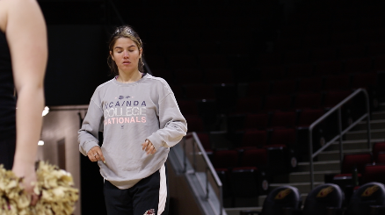(⅖ pom)  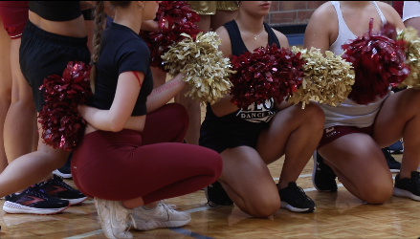  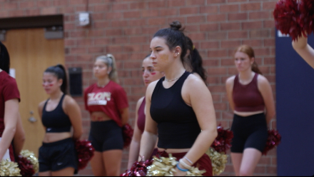  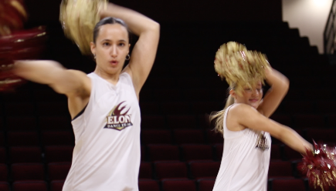  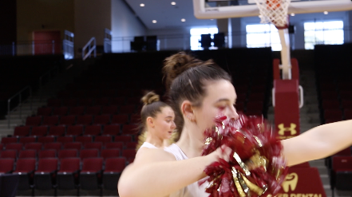  Isabella Interview  Kristin interview footage  B-Roll: clinics  The girls moving tables out of their practice space  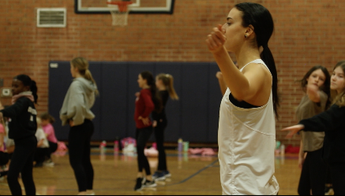  7:00AM  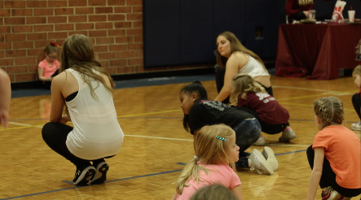  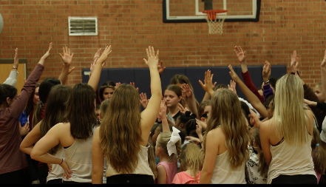  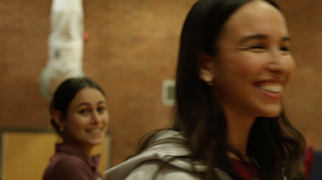  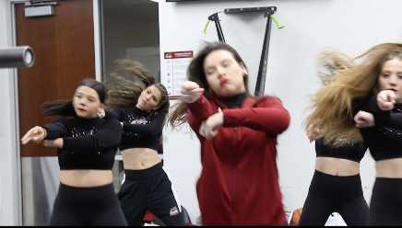  6:00PM  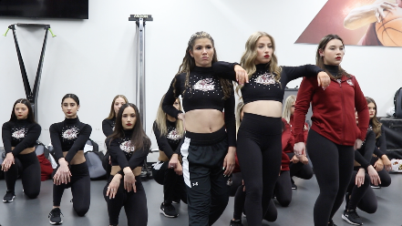  Devyn Interview  B-Roll: Devyn  Kristin Interview:  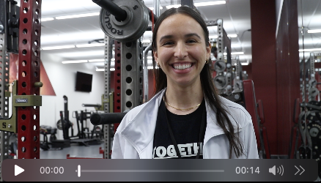  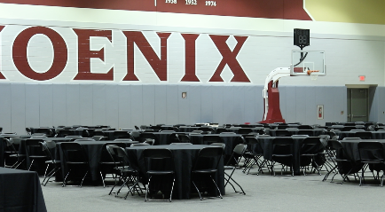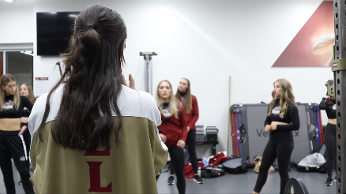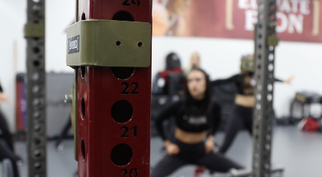  Ava Interview  B-Roll & Sarah Interview: 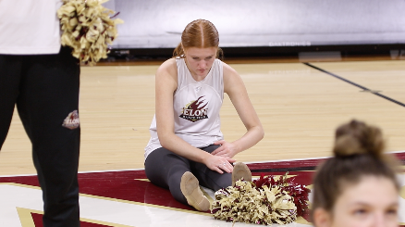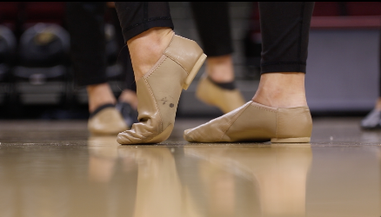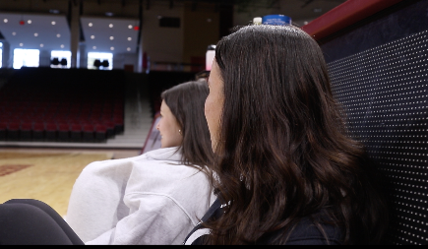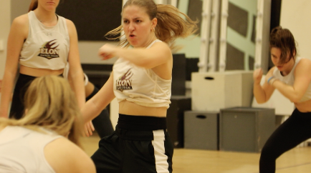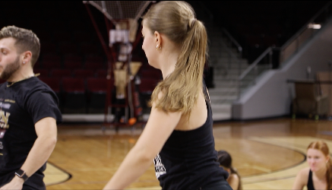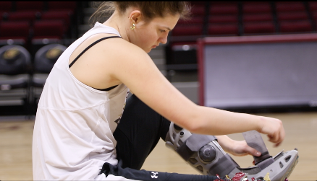  Kristin interview  <Possibly do a static student profile of Devyn and Isabella on website>  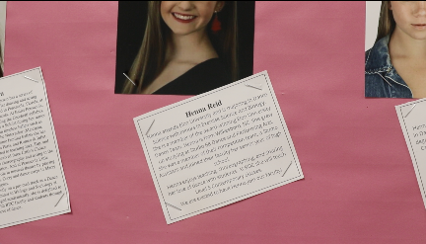  Emily Interview  B-Roll (12/11)  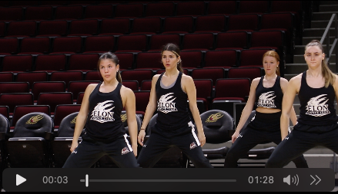12/10: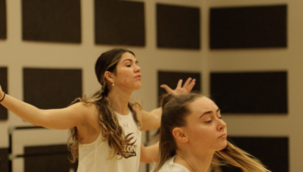<need a powerful ending clip here> | Ava’s Interview Audio: “When anyone is not protected by Title IX they are left vulnerable to a series of abuses that would be illegal if it was most other sports on campuses. I think dance team programs are made up overwhelmingly of female athletes and so the exclusion from Title IX disproportionately harms female athletes, and so again, I do not think you need to be a national championship winning team to be deserving of very basic respect, opportunity, and resources. Without Title IX protection we are left vulnerable and we don’t have grounds to do anything about it other than to share our story and hope that people listen.”  Ava’s Interview Audio: “For people that don’t know, NDA camp is… [and] for programs that are underfunded, which is the case for most dance teams, it’s very important for us to receive a high bid at NDA camp.”  “When we come to campus for pre-season [each August] we are not provided food like any other team would be provided despite our days lasting 9am-9pm. We drive ourselves in a van to NDA camp in the hopes of receiving a good enough bid to qualify for nationals in April.  Ava’s explanation of the NDA conditions: (lack of appropriate food, safe practice space for high-impact dancing)  Isabella’s Interview Audio: “We do hope one day to receive similar resources as other athletes like donations from [events] which we typically attend but don’t receive funds from.”  Kristin Interview Audio: (3: 13:20) “What a typical weekend looks like for a dance team member…”  Devyn Interview Audio: “It would be nice to have a locker room because we’re constantly pushed around into other peoples’ spaces and we are in need of an area to put our poms and nationals trophies and the workout equipment that we ourselves have bought”  Kristin Interview Audio:  (audio 1) / min 12:55) “It is sometimes difficult to find practice space…”  -(audio 3, 13:11- funding dance team necessities) and audio 3,ending  -audio 4, beginning: multitude of jobs  -audio 6, 14:04- not getting paid as an assistant coach)  Ava Interview Audio: “I am very grateful to be a conditioning captain and lead workouts for our team but I am not qualified to be a workout leader and we are denied the resources and facilities that would allow us to workout properly.”  Kristin Interview Audio: stress fractures (minute 10ish of her 1st audio)  -Kristin audio 3 (min 13:10ish): sophomore year experience w pain in lower legs and not getting proper medical attention/getting dismissed by professionals  Sarah Interview Audio: Sarah’s doctor story  Kristin Interview Audio: Class overlapping w practice times (latter half of Kristin audio 1) plus academic assistance because they’re involved in so many extracurriculars (Kristin audio 5, 13:44ish)  Emily Interview Audio: Lack of academic assistance, exclusion from athletics despite cheer and mascots’ inclusion  - “Not all dance teams are created equal”  - “Not all coaches will treat you well”  Ava Interview Audio: “The biases and discrimination that we have faced… is a challenge when you’re living out your dream as a college dancer”  +“I’ve been here for 5 years and the progression of this team has been incremental and not as fast as I think it should be. We’ve waited long enough. We’ve done enough. We’re worth enough and I don’t feel like waiting any longer.”
3  Breaking down stereotypes. What don’t people know about dance teams? What are people typically? confused about? | 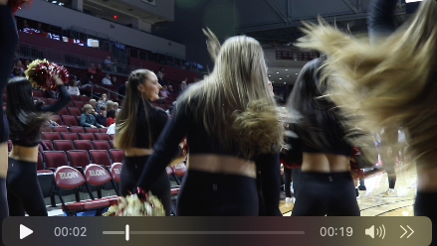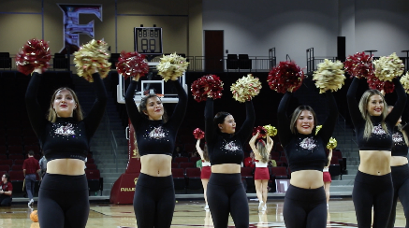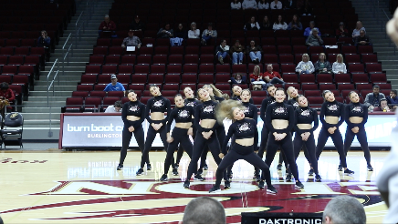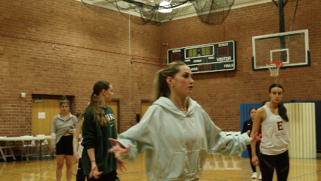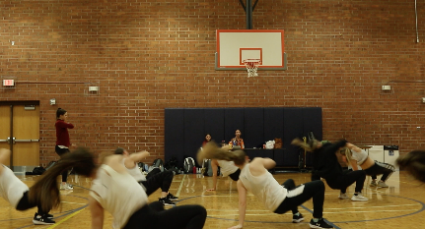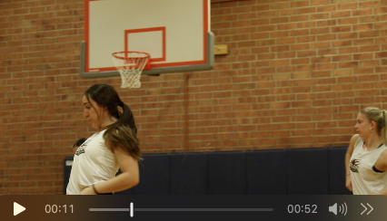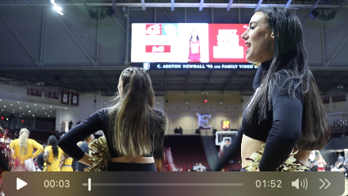  <Insert more B-Roll from Nationals practices>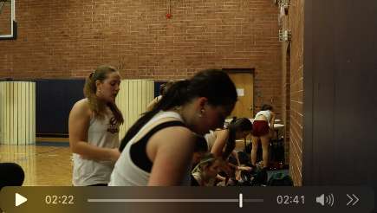  B-Roll:  Poms  Basketball game  Kristin Interview  Emily Interview  More dancing (Look Alive?) | Lindsey/Isabella Interview Audio?: Nationals: “When others aren’t exposed to the dance team world, they don’t know that we have an entirely separate and incredibly involved Nationals conditioning regimen alongside our so-called “spirit season.” So not only are we devoted to dancing at all basketball and football games, constantly turning over routines week after week, hosting clinics for the community, completing service hours for SAAC, etc., we’re also training August-April to compete for our nationals routines which are highly physical and strenuous.”  Emily Interview Audio: Difference between dance and cheer  Kristin Interview Audio: Difference between dance and cheer  +how long it takes to learn routines (“the rain routine” story) : Kristin audio 1  + “Why are dance team members athletes?” end of Kristin audio 1 / beginning of audio 2  +latter half of Kristin’s audio- maybe the athlete run-in story?  +audio 5, 13:41 sexual harassment, aesthetics-based sport  Emily Interview Audio: Brickyard preacher story  +How will dance break the barrier of not being a sport?
4  What are we excited about? What makes dance teams strong? | B-Roll:  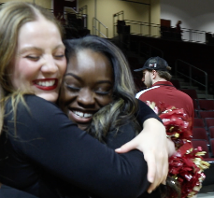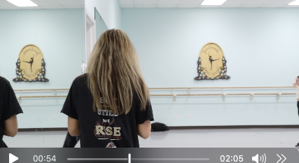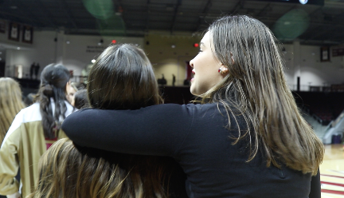 | Kristin Interview Audio: audio 3: 13:23 Nationals prep/ practice mats at 13:25 / practicing beforehand, practicing on concrete/parks, etc / emphasis on heart of the team  +Kristin audio 5, 13:44, most rewarding part about coaching  +Kristin audio 5, 13:51, winning Nationals and being recognized as a sport  Emily Interview Audio: What makes dance appealing as an entity/what keeps people coming back  Kristin Interview Audio:  “Why is dance a sport”  +Kristin audio 5, 13:51, the journey/history and what makes the team especially strong, = now wanting to uphold a high bar and even surpass it; “We show up for our sport and for every individual on the team”  EMILY AUDIO: RENT IS DUE  +Kristin audio 6 (audio 3) 14:07 : athletic director story “first athlete to win a natty champ in over 40 years” and “how that recognition speaks volumes to the growth of our program”

Sprint 3
The specific deliverable for Sprint 3 was a rough cut of one video. I delivered my “introduction/trailer” video (I had decided in my narrative to split up my videos into four parts). I pieced together audio and video to create an introduction video that is meant for viewers to take a quick look into the athleticism, the family bond, and the struggles the team grapples with behind the scenes. Additionally, I got great feedback after the presentation of my Sprint 3 but it will involve me re-orienting my introduction video quite a bit to allow users to better understand the story I’m trying to convey. Since submitting my script in the last retrospective I’ve realized that I may have to narrate elements myself, and/or include my voice asking questions in the interviews to clarify to the audience what’s going on. This is because in my original rough cut of the introduction video, the message that Assistant Coach Kristin sends is totally separate from what Ava sends. I may decide to flip Ava and Kristin’s parts but include Ava’s resonating words at the end to lead into Video 2 about Title IX, NDA, and the history of the EUDT. Also, in order to clarify Ava’s statements about discrimination and coaching I will either have to bring in Sarina, narrate myself, or include text on the screen about Rhonda’s statement (8 coaches in 16 years). Before next Monday, April 24th, I aim to roughly complete all my videos, complete user testing, nail the storytelling of the videos, and have an outline of my Ceros site. My user testing will aid in clarifying my storytelling strength and I’m aiming to do that on Sunday, April 23rd.
Sprint 4
According to my backlog the specific tasks I needed to complete for Sprint 4 and Project Ready Day were an outline of my Ceros site and four rough cuts of the videos I planned to create. To complete those tasks I needed to learn Ceros tutorials from Kelly Dunville, iMedia alumna, and also watch Youtube videos to gain technical skills and inspiration and get my ideas organized. I also needed to cut together all of the interviews I did, put B-Roll on top of clips, add music, lower third introductions, and figure out how I'd properly explain Title IX to viewers. I spent a lot of time on Premiere Pro fixing audio and music levels, cutting down interviews, matching video to audio, putting B-Roll in, creating lower thirds, and piecing together the story so that it makes sense. Since submitting my previous retrospectives I have decided to create two (2) videos to place on Youtube instead of four (4) because my first video will introduce the topic and the second video is a 21 minute documentary that explains the strength of dance teams as well their conflict with Title IX. I have re-shaped my original script to enhance the narrative and will split up my second video into 5 parts. This is because I breakdown the Title IX regulation into 5 provisions. I will also put those 5 provisions on the site. I cut down my introduction video from 4 minutes and 36 seconds to 3 minutes and 57 seconds. The video better introduces the concept by starting with the dancers in action first, followed by Ava’s commentary about their struggles with Title IX, and how far the program has excelled despite them.

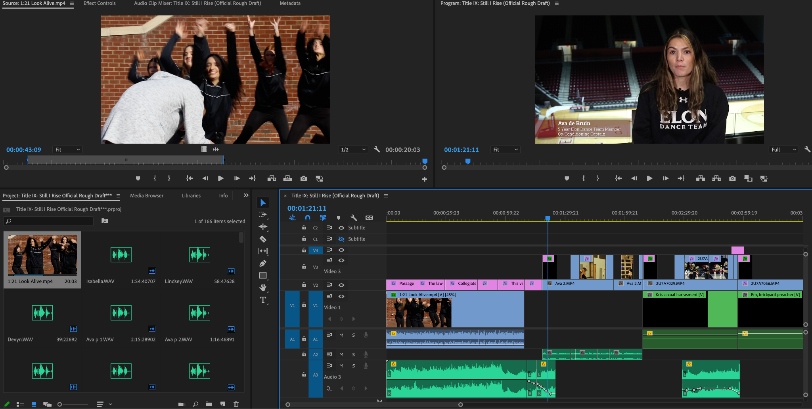
Sprint 5

For Sprint 5 I planned to put finishing touches on my videos and website. I organized my site onto Ceros so that a user could follow my story and eventually the process I took to complete my project behind the scenes. I used interactive elements like graphic animations of the dancers, clickable videos/interviews, clickable graphics, moving quotes, and clickable calls-to-action. I also used automatic videos and outlined Title IX generally and by sections; I broke down the Title IX provisions by visually appealing cards which take the viewers to the part of the documentary that explains each provision directly. I color corrected teaser/highlight videos and learned how to use the design, interact and animate features on Ceros. Finally I presented the product to my peers and got feedback to improve the final product. I learned that the title of my project that I originally intended to go with was used by a peer in previous years so I scratched that and created my current title. I had a “Demo Day” where I practiced pitching my interactive website and documentary to peers and mentors. I learned how to present my information effectively, whether that be about my narrative or about my process.
Project Reflection
Titles and Trophies: The Dance Dilemma has allowed me an authentic context to ideate, design, develop and publicize a notable interactive media project. Individually I have developed skills that include but are not limited to time management, theory and audience analysis, pre-production, production, post-production, and interactive storytelling. I learned how to create a successful video marketing strategy: to create engaging and quality content that builds trust in order to enact change. I learned that adding a video to your website can increase the chance of a front page google result by 53 times, that 79% of people would rather watch a video to learn than read text, and that Youtube videos rank near the top of a search engine results page (HubSpot Academy, n.d.). As a result I invested wholeheartedly in this documentary and put both the trailer and the full video on Youtube. I learned that interactive storytelling helps the audience better visualize the story being told and the message conveyed. I learned that the agile methodology is an effective way of giving and receiving feedback on a project. Interactive storytelling on Ceros has allowed me to refine my Photoshop and Illustrator skills. On Ceros I have animations that allowed me to utilize the pen tool, object selection tool, magic wand tool, masking tool, and others. On Premiere Pro I refined my audio work, with a goal of keeping levels between -18 and -6. I faded music in and out with keyframes. I spent a lot of time with color correction, lower-thirds, and making sure B-Roll, text, and interview clips effectively emphasized the narrative. All Adobe platforms, Ceros, as well as the production and post-maintenance of production content require an extreme level of organization and I believe I was able to handle this effectively. I demonstrated leadership through the initiation of several interviews for this project. Working alone on a 20 minute documentary, a trailer and an interactive website will naturally come with challenges. Some of those challenges were the reconstruction of storyboards and scripts, the extension of research after losing an interview source, and learning new platforms as you go. Some may say I was “building the ship while sailing it.”
Credits:
American Student Athlete Logistics. (2022, February 19). NCAA, NAIA, NJCAA, NCCAA, CCCAA & USCAA. American Student Athlete Logistics. https://asalsports.org/resources/ncaa-naia-njcaa-nccaa-cccaa-uscaa/
Balagtas, T. (2022, January 24). Watch the Incredible, Nationals-Winning LSU Dance Team Routine That's Going Viral. People. Retrieved February 7, 2023, from https://people.com/sports/lsu-dance-team-viral-like-a-boy-dance/
Department of Health, Education and Welfare, Office for Civil Rights, Office of the Secretary. (1979, December 11). A Policy Interpretation: Title IX and Intercollegiate Athletics, 44(239). U.S. Department of Education. https://www2.ed.gov/about/offices/list/ocr/docs/t9interp.html
Elon Athletics
Ewalt K.L., (2010). Athletic training in dance medicine and science. Journal of Dance Medicine & Science : Official Publication of the International Association for Dance Medicine & Science, 14(3), 79–81. https://www.ingentaconnect.com/contentone/jmrp/jdms/2010/00000014/00000003/art00001?crawler=true&mimetype=application/pdf
Hart, J. (2023, February 3). Division I University Cheerleaders refuse to perform at basketball game after getting ignored on 'Women in Sports Day'. Insider. https://www.businessinsider.com/st-johns-university-accused-of-snubbing-cheer-team-protest-ensues-2023-2
HubSpot Academy (n.d.) Digital Marketing. HubSpot. https://app.hubspot.com/academy/21922159/tracks/117/exam
K. Sicari, personal communication, December 4, 2022
Knavel, J. (2023, February 27). Elon Athletics Launches Forever Phoenix, An NIL Network For Student-Athletes. Elon Phoenix. https://elonphoenix.com/news/2023/2/27/elon-athletics-launches-official-nil-marketplace-for-student-athletes.aspx
NAIA. (2023, March 10). 2023 NAIA Competitive Dance National Championship Recap - Day One. NAIA.org. https://www.naia.org/sports/dance/2022-23/Releases/Prelim_Recap#:~:text=%E2%80%93%20The%20opening%20day%20of%20the,been%20held%20in%20Ypsilanti%2C%20Mich.
National Coalition for Women and Girls in Education (NCWGE). Title IX at 40: Working to Ensure Gender Equity in Education. Washington, DC: NCWGE, 2012.
NCAA. (n.d.). NCAA Emerging Sports for Women Process Guide. NCAA.org. https://www.ncaa.org/sports/2016/8/26/ncaa-emerging-sports-for-women-process-guide.aspx
NCAA. NCAA Name, Image, Likeness Rule. NCSA College Recruiting. (n.d.). https://www.ncsasports.org/name-image-likeness
Office of Civil Rights. (2020, January 16). Athletics. U.S. Department of Education. https://www2.ed.gov/about/offices/list/ocr/frontpage/pro-students/issues/sex-issue04.html
Price, E.O., (2022). Not Just Pretty Girls with Pom Poms: An Argument for the NCAA and the Office of Civil Rights to Recognize Collegiate Dance Teams as a Sport. http://dx.doi.org/10.2139/ssrn.4038444
R. Belton, personal communication, December 4, 2022
Rich, J., Pottratz, S. T., & Perreault, M. (2022). Strategies for early peak performance artistic athletes’ retirement from sport. Strategies, 35(2), 3–7. https://doi.org/10.1080/08924562.2022.2030833
The United States Department of Justice. (2001, August 12). Title IX. The United States Department of Justice. https://www.justice.gov/crt/title-ix#I.%20Overview%20of%20Title%20IX:%20Interplay%20with%20Title%20VI,%20Section%20504,%20Title%20VII,%20and%20the%20Fourteenth%20Amendment
USA Cheer. (2023, January 19). Stunt moves forward as NCAA DII Emerging Sport. USA Cheer. https://usacheer.org/stunt-moves-forward-as-ncaa-dii-emerging-sport
Varsity Spirit

